Momentum Fund Communications Toolkit

Press Release
Click here to access the press release and announcement for the Momentum Fund.

Newsletter
Here’s a blurb you can use in your newsletter to promote the Momentum Fund:

Momentum Fund to Help Build Capacity of Nonprofits Managing COVID-19 Funds

The recently launched Momentum Fund will support nonprofit organizations managing active COVID-19 relief and recovery funds that are helping communities recover from the COVID-19 pandemic. The Fund will award grants of up to $100,000 to 501(c)(3) organizations managing COVID-19 funds that are providing grants to other 501(c)(3) organizations meeting the needs of communities and populations whose health and/or financial situations have been most severely impacted by the COVID-19 pandemic and who have been historically marginalized in our country.

The Fund will award a total of $8.5 million in grants to help these organizations build their internal capacity to more effectively grow, promote, manage and sustain their funds. The grants can be used to add new staff, acquire new cutting-edge technology, or address other pressing capacity needs. Applications for the Momentum Fund will be accepted through 3:00 pm ET on Thursday, June 18, 2020.

The Momentum Fund is managed by United Philanthropy Forum and has been made possible by a grant from the Bill & Melinda Gates Foundation. To learn more, visit www.momentumfund.org.

Social Media

Sample Tweets
- New #MomentumFund will help build capacity of nonprofits managing #COVID19 funds, for funds focused on communities most impacted by pandemic and historically marginalized; learn more: www.momentumfund.org
- #MomentumFund grant opportunity for 501c3 orgs managing #COVID19 funds: capacity-building grants up to $100K for groups w/funds supporting nonprofits helping communities most severely impacted by virus and historically marginalized; 6/18 deadline www.momentumfund.org
- Do you know a nonprofit managing a #COVID19 relief fund? #MomentumFund is accepting applications until 6/18 for grants up to $100K to support 501c3 orgs providing #COVID19 funding to nonprofits serving our most vulnerable communities. Learn more: www.momentumfund.org

Sample Facebook Post

The recently launched #MomentumFund will support 501(c)(3) organizations managing active COVID-19 relief and recovery funds that are helping communities recover from the COVID-19 pandemic. The Fund will award $8.5 million in grants of up to $100,000 to 501(c)(3) organizations managing COVID-19 funds that are providing grants to other 501(c)(3) organizations meeting the needs of communities and populations whose health and/or financial situations have been most severely impacted by the COVID-19 pandemic and who have been historically marginalized in our country. The Momentum Fund is managed by United Philanthropy Forum and has been made possible by a grant from the Bill & Melinda Gates Foundation. Application deadline is June 18. Learn more at www.momentumfund.org.

Twitter Image

Facebook Image

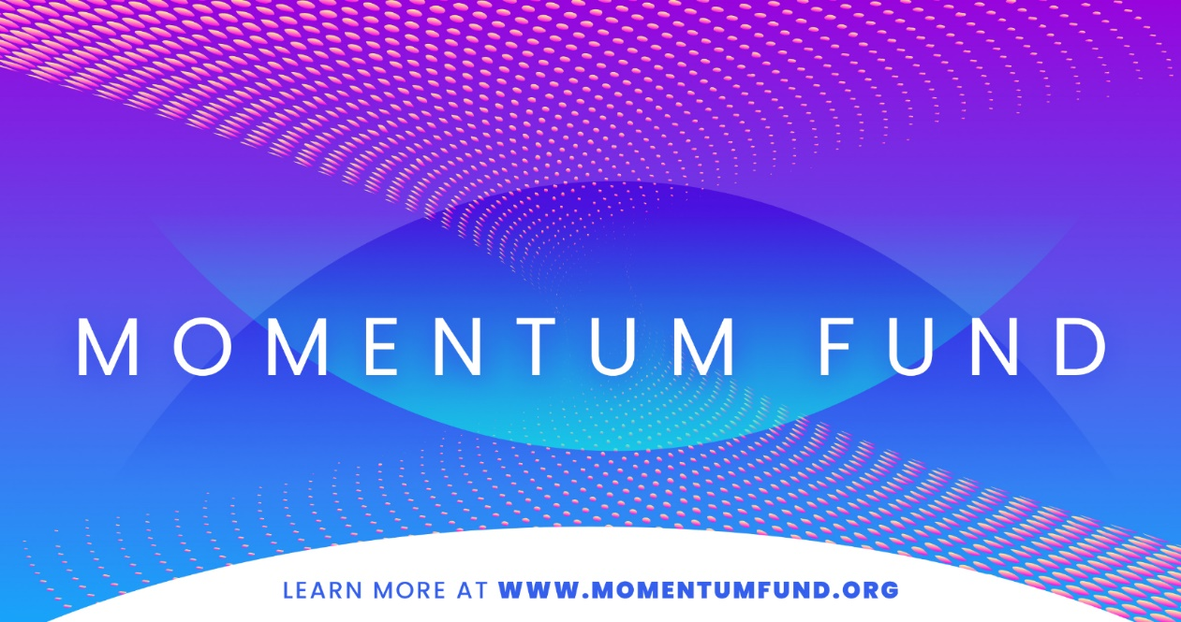

Download Social Media Image Files

