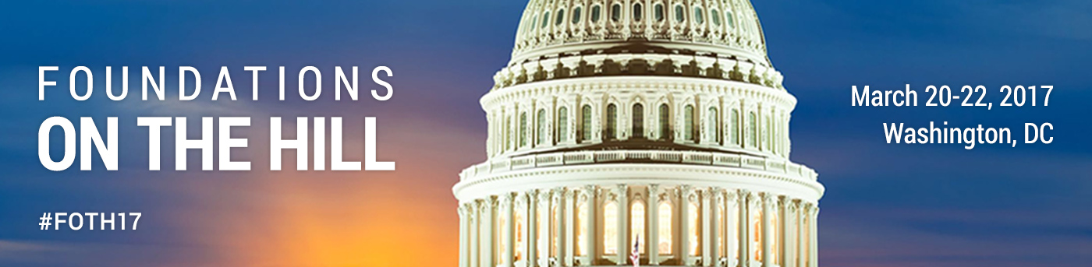

Get Social at FOTH using the hashtag #FOTH17
Follow @givingforum throughout the conference!

Retweet our posts about FOTH’s events and key messages. Share your own stories using the #FOTH17 hashtag and the Twitter accounts of members of Congress you visit throughout the week - get these ready ahead of time, you can find them in the Congressional Directory which you will receive at the ACR Summit.

Important Details
- Use #FOTH17 for any of your social media posts on Twitter or Facebook.
- Add #100yearsofgiving to widen your outreach
- Follow the Forum throughout Foundations on the Hill: Twitter: @givingforum

General Tips for Live Reporting From FOTH and Your Hill Meetings
- Post only the most interesting quotes and stats presented by event speakers. Listen carefully and be selective. The goal is not to repeat verbatim all that is being said, but rather to share the most impressive highlights.
- Attribute when possible! For example, use a format like “[name/Twitter handle] says [statement]. #FOTH17”.
- Use the event hashtag (#FOTH17) in every tweet, update, and post.
- Retweet the speakers and attendees that are also live reporting.
- Identify the twitter handles of the members of Congress you will be meeting with and use that in your tweets about your meeting. Don’t forget to share a picture!
- Have fun and think of it as a way to journal your experience at Foundations on the Hill!

Top 4 Ways to Get You Started
#1 Tweet a photo with your member of Congress or staff
#2 Tweet out a thank you to your member or Congress and/or staff
#3 Tweet a quote or something that you hear that’s interesting
#4 Tweet about the issues that you care about, but keep it short and sweet

Sample Tweets
- Thrilled to be in DC for Foundations on the Hill talking about OH philanthropy’s role helping communities thrive & improving lives #FOTH17
- Excited to talk with @SenStabenow abt philanthropy’s unique ability to innovate, incubate and deliver results for Michigan #FOTH17
- Great talking with @sendavidperdue about GA philanthropy at #FOTH17and how @secftweets can be a resource for him and others in Congress
- Govt/foundation partnership around education, health/human services & economy = why we need charitable tax deduction @flphilanthropy #FOTH17

